Java Control Statements | Control Flow in Java

Java compiler executes the code from top to bottom. The statements in the code are executed according to the order in which they appear. However, [Java](https://www.javatpoint.com/java-tutorial) provides statements that can be used to control the flow of Java code. Such statements are called control flow statements. It is one of the fundamental features of Java, which provides a smooth flow of program.

Java provides three types of control flow statements.

1. Decision Making statements
   * if statements
   * switch statement
2. Loop statements
   * do while loop
   * while loop
   * for loop
   * for-each loop
3. Jump statements
   * break statement
   * continue statement

Decision-Making statements:

As the name suggests, decision-making statements decide which statement to execute and when. Decision-making statements evaluate the Boolean expression and control the program flow depending upon the result of the condition provided. There are two types of decision-making statements in Java, i.e., If statement and switch statement.

1) If Statement:

In Java, the "if" statement is used to evaluate a condition. The control of the program is diverted depending upon the specific condition. The condition of the If statement gives a Boolean value, either true or false. In Java, there are four types of if-statements given below.

1. Simple if statement
2. if-else statement
3. if-else-if ladder
4. Nested if-statement

Let's understand the if-statements one by one.

1) Simple if statement:

It is the most basic statement among all control flow statements in Java. It evaluates a Boolean expression and enables the program to enter a block of code if the expression evaluates to true.

Syntax of if statement is given below.

1. **if**(condition) {
2. statement 1; //executes when condition is true
3. }

Consider the following example in which we have used the **if** statement in the java code.

Student.java

**Student.java**

1. **public** **class** Student {
2. **public** **static** **void** main(String[] args) {
3. **int** x = 10;
4. **int** y = 12;
5. **if**(x+y > 20) {
6. System.out.println("x + y is greater than 20");
7. }
8. }
9. }

**Output:**

x + y is greater than 20

2) if-else statement

The [if-else statement](https://www.javatpoint.com/java-if-else) is an extension to the if-statement, which uses another block of code, i.e., else block. The else block is executed if the condition of the if-block is evaluated as false.

**Syntax:**

1. **if**(condition) {
2. statement 1; //executes when condition is true
3. }
4. **else**{
5. statement 2; //executes when condition is false
6. }

Consider the following example.

**Student.java**

1. **public** **class** Student {
2. **public** **static** **void** main(String[] args) {
3. **int** x = 10;
4. **int** y = 12;
5. **if**(x+y < 10) {
6. System.out.println("x + y is less than      10");
7. }   **else** {
8. System.out.println("x + y is greater than 20");
9. }
10. }
11. }

**Output:**

x + y is greater than 20

3) if-else-if ladder:

The if-else-if statement contains the if-statement followed by multiple else-if statements. In other words, we can say that it is the chain of if-else statements that create a decision tree where the program may enter in the block of code where the condition is true. We can also define an else statement at the end of the chain.

Syntax of if-else-if statement is given below.

1. **if**(condition 1) {
2. statement 1; //executes when condition 1 is true
3. }
4. **else** **if**(condition 2) {
5. statement 2; //executes when condition 2 is true
6. }
7. **else** {
8. statement 2; //executes when all the conditions are false
9. }

Consider the following example.

**Student.java**

1. **public** **class** Student {
2. **public** **static** **void** main(String[] args) {
3. String city = "Delhi";
4. **if**(city == "Meerut") {
5. System.out.println("city is meerut");
6. }**else** **if** (city == "Noida") {
7. System.out.println("city is noida");
8. }**else** **if**(city == "Agra") {
9. System.out.println("city is agra");
10. }**else** {
11. System.out.println(city);
12. }
13. }
14. }

**Output:**

Delhi

4. Nested if-statement

In nested if-statements, the if statement can contain a **if** or **if-else** statement inside another if or else-if statement.

Syntax of Nested if-statement is given below.

1. **if**(condition 1) {
2. statement 1; //executes when condition 1 is true
3. **if**(condition 2) {
4. statement 2; //executes when condition 2 is true
5. }
6. **else**{
7. statement 2; //executes when condition 2 is false
8. }
9. }

Consider the following example.

**Student.java**

1. **public** **class** Student {
2. **public** **static** **void** main(String[] args) {
3. String address = "Delhi, India";
5. **if**(address.endsWith("India")) {
6. **if**(address.contains("Meerut")) {
7. System.out.println("Your city is Meerut");
8. }**else** **if**(address.contains("Noida")) {
9. System.out.println("Your city is Noida");
10. }**else** {
11. System.out.println(address.split(",")[0]);
12. }
13. }**else** {
14. System.out.println("You are not living in India");
15. }
16. }
17. }

**Output:**

Delhi

Switch Statement:

In Java, [Switch statements](https://www.javatpoint.com/java-switch) are similar to if-else-if statements. The switch statement contains multiple blocks of code called cases and a single case is executed based on the variable which is being switched. The switch statement is easier to use instead of if-else-if statements. It also enhances the readability of the program.

Points to be noted about switch statement:

* The case variables can be int, short, byte, char, or enumeration. String type is also supported since version 7 of Java
* Cases cannot be duplicate
* Default statement is executed when any of the case doesn't match the value of expression. It is optional.
* Break statement terminates the switch block when the condition is satisfied.  
  It is optional, if not used, next case is executed.
* While using switch statements, we must notice that the case expression will be of the same type as the variable. However, it will also be a constant value.

The syntax to use the switch statement is given below.

1. **switch** (expression){
2. **case** value1:
3. statement1;
4. **break**;
5. .
6. .
7. .
8. **case** valueN:
9. statementN;
10. **break**;
11. **default**:
12. **default** statement;
13. }

Consider the following example to understand the flow of the switch statement.

**Student.java**

1. **public** **class** Student **implements** Cloneable {
2. **public** **static** **void** main(String[] args) {
3. **int** num = 2;
4. **switch** (num){
5. **case** 0:
6. System.out.println("number is 0");
7. **break**;
8. **case** 1:
9. System.out.println("number is 1");
10. **break**;
11. **default**:
12. System.out.println(num);
13. }
14. }
15. }

**Output:**

2

While using switch statements, we must notice that the case expression will be of the same type as the variable. However, it will also be a constant value. The switch permits only int, string, and Enum type variables to be used.

Loop Statements

In programming, sometimes we need to execute the block of code repeatedly while some condition evaluates to true. However, loop statements are used to execute the set of instructions in a repeated order. The execution of the set of instructions depends upon a particular condition.

In Java, we have three types of loops that execute similarly. However, there are differences in their syntax and condition checking time.

1. for loop
2. while loop
3. do-while loop

Let's understand the loop statements one by one.

Java for loop

In Java, [for loop](https://www.javatpoint.com/java-for-loop) is similar to [C](https://www.javatpoint.com/c-programming-language-tutorial) and [C++](https://www.javatpoint.com/cpp-tutorial). It enables us to initialize the loop variable, check the condition, and increment/decrement in a single line of code. We use the for loop only when we exactly know the number of times, we want to execute the block of code.

1. **for**(initialization, condition, increment/decrement) {
2. //block of statements
3. }

The flow chart for the for-loop is given below.

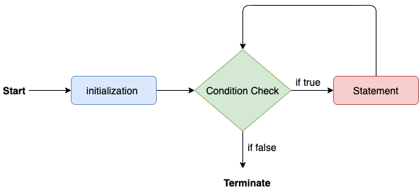

Consider the following example to understand the proper functioning of the for loop in java.

**Calculation.java**

1. **public** **class** Calculattion {
2. **public** **static** **void** main(String[] args) {
3. // TODO Auto-generated method stub
4. **int** sum = 0;
5. **for**(**int** j = 1; j<=10; j++) {
6. sum = sum + j;
7. }
8. System.out.println("The sum of first 10 natural numbers is " + sum);
9. }
10. }

**Output:**

The sum of first 10 natural numbers is 55

Java for-each loop

Java provides an enhanced for loop to traverse the data structures like array or collection. In the for-each loop, we don't need to update the loop variable. The syntax to use the for-each loop in java is given below.

1. **for**(data_type var : array_name/collection_name){
2. //statements
3. }

Consider the following example to understand the functioning of the for-each loop in Java.

**Calculation.java**

1. **public** **class** Calculation {
2. **public** **static** **void** main(String[] args) {
3. // TODO Auto-generated method stub
4. String[] names = {"Java","C","C++","Python","JavaScript"};
5. System.out.println("Printing the content of the array names:\n");
6. **for**(String name:names) {
7. System.out.println(name);
8. }
9. }
10. }

**Output:**

Printing the content of the array names:

Java

C

C++

Python

JavaScript

Java while loop

The [while loop](https://www.javatpoint.com/java-while-loop) is also used to iterate over the number of statements multiple times. However, if we don't know the number of iterations in advance, it is recommended to use a while loop. Unlike for loop, the initialization and increment/decrement doesn't take place inside the loop statement in while loop.

It is also known as the entry-controlled loop since the condition is checked at the start of the loop. If the condition is true, then the loop body will be executed; otherwise, the statements after the loop will be executed.

The syntax of the while loop is given below.

1. **while**(condition){
2. //looping statements
3. }

The flow chart for the while loop is given in the following image.

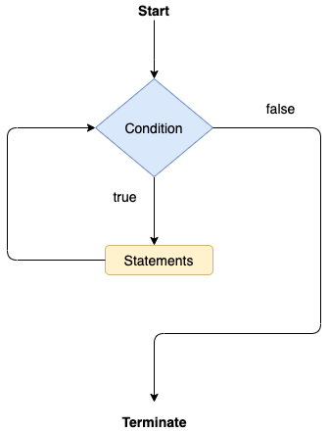

Consider the following example.

**Calculation .java**

1. **public** **class** Calculation {
2. **public** **static** **void** main(String[] args) {
3. // TODO Auto-generated method stub
4. **int** i = 0;
5. System.out.println("Printing the list of first 10 even numbers \n");
6. **while**(i<=10) {
7. System.out.println(i);
8. i = i + 2;
9. }
10. }
11. }

**Output:**

Printing the list of first 10 even numbers

0

2

4

6

8

10

Java do-while loop

The [do-while loop](https://www.javatpoint.com/java-do-while-loop) checks the condition at the end of the loop after executing the loop statements. When the number of iteration is not known and we have to execute the loop at least once, we can use do-while loop.

It is also known as the exit-controlled loop since the condition is not checked in advance. The syntax of the do-while loop is given below.

1. **do**
2. {
3. //statements
4. } **while** (condition);

The flow chart of the do-while loop is given in the following image.

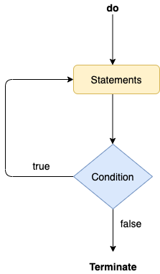

Consider the following example to understand the functioning of the do-while loop in Java.

**Calculation.java**

1. **public** **class** Calculation {
2. **public** **static** **void** main(String[] args) {
3. // TODO Auto-generated method stub
4. **int** i = 0;
5. System.out.println("Printing the list of first 10 even numbers \n");
6. **do** {
7. System.out.println(i);
8. i = i + 2;
9. }**while**(i<=10);
10. }
11. }

**Output:**

Printing the list of first 10 even numbers

0

2

4

6

8

10

Jump Statements

Jump statements are used to transfer the control of the program to the specific statements. In other words, jump statements transfer the execution control to the other part of the program. There are two types of jump statements in Java, i.e., break and continue.

Java break statement

As the name suggests, the [break statement](https://www.javatpoint.com/java-break) is used to break the current flow of the program and transfer the control to the next statement outside a loop or switch statement. However, it breaks only the inner loop in the case of the nested loop.

The break statement cannot be used independently in the Java program, i.e., it can only be written inside the loop or switch statement.

**The break statement example with for loop**

Consider the following example in which we have used the break statement with the for loop.

**BreakExample.java**

1. **public** **class** BreakExample {
3. **public** **static** **void** main(String[] args) {
4. // TODO Auto-generated method stub
5. **for**(**int** i = 0; i<= 10; i++) {
6. System.out.println(i);
7. **if**(i==6) {
8. **break**;
9. }
10. }
11. }
12. }

**Output:**

0

1

2

3

4

5

6

**break statement example with labeled for loop**

**Calculation.java**

1. **public** **class** Calculation {
3. **public** **static** **void** main(String[] args) {
4. // TODO Auto-generated method stub
5. a:
6. **for**(**int** i = 0; i<= 10; i++) {
7. b:
8. **for**(**int** j = 0; j<=15;j++) {
9. c:
10. **for** (**int** k = 0; k<=20; k++) {
11. System.out.println(k);
12. **if**(k==5) {
13. **break** a;
14. }
15. }
16. }
18. }
19. }

22. }

**Output:**

0

1

2

3

4

5

Java continue statement

Unlike break statement, the [continue statement](https://www.javatpoint.com/java-continue) doesn't break the loop, whereas, it skips the specific part of the loop and jumps to the next iteration of the loop immediately.

Consider the following example to understand the functioning of the continue statement in Java.

1. **public** **class** ContinueExample {
3. **public** **static** **void** main(String[] args) {
4. // TODO Auto-generated method stub
6. **for**(**int** i = 0; i<= 2; i++) {
8. **for** (**int** j = i; j<=5; j++) {
10. **if**(j == 4) {
11. **continue**;
12. }
13. System.out.println(j);
14. }
15. }
16. }
18. }

**Output:**

0

1

2

3

5

1

2

3

5

2

3

5

# Java If-else Statement

The [Java](https://www.javatpoint.com/java-tutorial) if statement is used to test the condition. It checks [boolean](https://www.javatpoint.com/boolean-keyword-in-java) condition: true or false. There are various types of if statement in Java.

* if statement
* if-else statement
* if-else-if ladder
* nested if statement

## Java if Statement

The Java if statement tests the condition. It executes the if block if condition is true.

**Syntax:**

1. **if**(condition){
2. //code to be executed
3. }

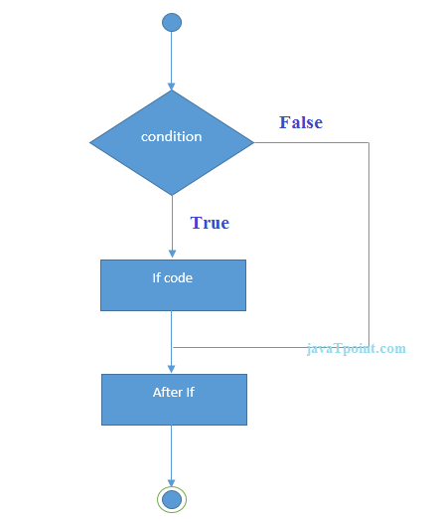

**Example:**

1. //Java Program to demonstate the use of if statement.
2. **public** **class** IfExample {
3. **public** **static** **void** main(String[] args) {
4. //defining an 'age' variable
5. **int** age=20;
6. //checking the age
7. **if**(age>18){
8. System.out.print("Age is greater than 18");
9. }
10. }
11. }

[**Test it Now**](https://compiler.javatpoint.com/opr/test.jsp?filename=IfExample)

Output:

Age is greater than 18

## Java if-else Statement

The Java if-else statement also tests the condition. It executes the if block if condition is true otherwise else block is executed.

**Syntax:**

1. **if**(condition){
2. //code if condition is true
3. }**else**{
4. //code if condition is false
5. }

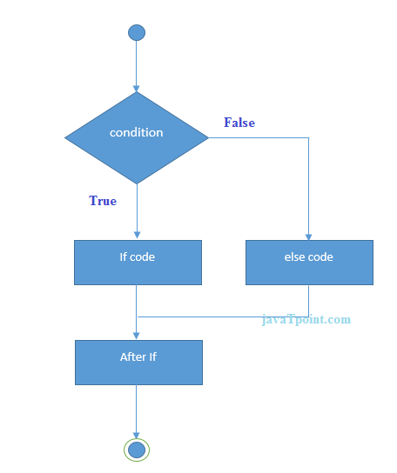

**Example:**

1. //A Java Program to demonstrate the use of if-else statement.
2. //It is a program of odd and even number.
3. **public** **class** IfElseExample {
4. **public** **static** **void** main(String[] args) {
5. //defining a variable
6. **int** number=13;
7. //Check if the number is divisible by 2 or not
8. **if**(number%2==0){
9. System.out.println("even number");
10. }**else**{
11. System.out.println("odd number");
12. }
13. }
14. }

[**Test it Now**](https://compiler.javatpoint.com/opr/test.jsp?filename=IfElseExample)

Output:

odd number

**Leap Year Example:**

A year is leap, if it is divisible by 4 and 400. But, not by 100.

1. **public** **class** LeapYearExample {
2. **public** **static** **void** main(String[] args) {
3. **int** year=2020;
4. **if**(((year % 4 ==0) && (year % 100 !=0)) || (year % 400==0)){
5. System.out.println("LEAP YEAR");
6. }
7. **else**{
8. System.out.println("COMMON YEAR");
9. }
10. }
11. }

Output:

LEAP YEAR

## Using Ternary Operator

We can also use ternary operator (? :) to perform the task of if...else statement. It is a shorthand way to check the condition. If the condition is true, the result of ? is returned. But, if the condition is false, the result of : is returned.

**Example:**

1. **public** **class** IfElseTernaryExample {
2. **public** **static** **void** main(String[] args) {
3. **int** number=13;
4. //Using ternary operator
5. String output=(number%2==0)?"even number":"odd number";
6. System.out.println(output);
7. }
8. }

Output:

odd number

## Java if-else-if ladder Statement

The if-else-if ladder statement executes one condition from multiple statements.

**Syntax:**

1. **if**(condition1){
2. //code to be executed if condition1 is true
3. }**else** **if**(condition2){
4. //code to be executed if condition2 is true
5. }
6. **else** **if**(condition3){
7. //code to be executed if condition3 is true
8. }
9. ...
10. **else**{
11. //code to be executed if all the conditions are false
12. }

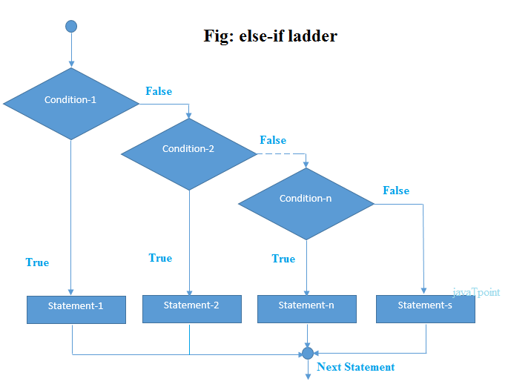

**Example:**

1. //Java Program to demonstrate the use of If else-if ladder.
2. //It is a program of grading system for fail, D grade, C grade, B grade, A grade and A+.
3. **public** **class** IfElseIfExample {
4. **public** **static** **void** main(String[] args) {
5. **int** marks=65;
7. **if**(marks<50){
8. System.out.println("fail");
9. }
10. **else** **if**(marks>=50 && marks<60){
11. System.out.println("D grade");
12. }
13. **else** **if**(marks>=60 && marks<70){
14. System.out.println("C grade");
15. }
16. **else** **if**(marks>=70 && marks<80){
17. System.out.println("B grade");
18. }
19. **else** **if**(marks>=80 && marks<90){
20. System.out.println("A grade");
21. }**else** **if**(marks>=90 && marks<100){
22. System.out.println("A+ grade");
23. }**else**{
24. System.out.println("Invalid!");
25. }
26. }
27. }

Output:

C grade

**Program to check POSITIVE, NEGATIVE or ZERO:**

1. **public** **class** PositiveNegativeExample {
2. **public** **static** **void** main(String[] args) {
3. **int** number=-13;
4. **if**(number>0){
5. System.out.println("POSITIVE");
6. }**else** **if**(number<0){
7. System.out.println("NEGATIVE");
8. }**else**{
9. System.out.println("ZERO");
10. }
11. }
12. }

Output:

NEGATIVE

## Java Nested if statement

The nested if statement represents the if block within another if block. Here, the inner if block condition executes only when outer if block condition is true.

**Syntax:**

1. **if**(condition){
2. //code to be executed
3. **if**(condition){
4. //code to be executed
5. }
6. }

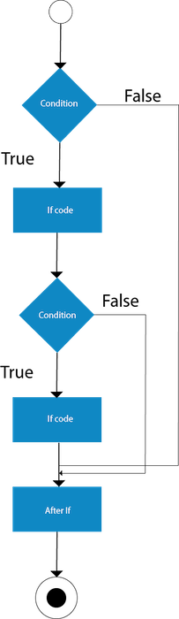

**Example:**

1. //Java Program to demonstrate the use of Nested If Statement.
2. **public** **class** JavaNestedIfExample {
3. **public** **static** **void** main(String[] args) {
4. //Creating two variables for age and weight
5. **int** age=20;
6. **int** weight=80;
7. //applying condition on age and weight
8. **if**(age>=18){
9. **if**(weight>50){
10. System.out.println("You are eligible to donate blood");
11. }
12. }
13. }}

[**Test it Now**](https://compiler.javatpoint.com/opr/test.jsp?filename=JavaNestedIfExample)

Output:

You are eligible to donate blood

**Example 2:**

1. //Java Program to demonstrate the use of Nested If Statement.
2. **public** **class** JavaNestedIfExample2 {
3. **public** **static** **void** main(String[] args) {
4. //Creating two variables for age and weight
5. **int** age=25;
6. **int** weight=48;
7. //applying condition on age and weight
8. **if**(age>=18){
9. **if**(weight>50){
10. System.out.println("You are eligible to donate blood");
11. } **else**{
12. System.out.println("You are not eligible to donate blood");
13. }
14. } **else**{
15. System.out.println("Age must be greater than 18");
16. }
17. }  }

# Java Switch Statement

The Java switch statement executes one statement from multiple conditions. It is like [if-else-if](https://www.javatpoint.com/java-if-else) ladder statement. The switch statement works with byte, short, int, long, enum types, String and some wrapper types like Byte, Short, Int, and Long. Since Java 7, you can use [strings](https://www.javatpoint.com/java-string) in the switch statement.

In other words, the switch statement tests the equality of a variable against multiple values.

### Points to Remember

* There can be one or N number of case values for a switch expression.
* The case value must be of switch expression type only. The case value must be literal or constant. It doesn't allow [variables](https://www.javatpoint.com/java-variables).
* The case values must be unique. In case of duplicate value, it renders compile-time error.
* The Java switch expression must be of byte, short, int, long (with its Wrapper type), *[enums](https://www.javatpoint.com/java-switch)* and string.
* Each case statement can have a break statement which is optional. When control reaches to the [break statement](https://www.javatpoint.com/java-break), it jumps the control after the switch expression. If a break statement is not found, it executes the next case.
* The case value can have a default label which is optional.

**Syntax:**

1. **switch**(expression){
2. **case** value1:
3. //code to be executed;
4. **break**;  //optional
5. **case** value2:
6. //code to be executed;
7. **break**;  //optional
8. ......
10. **default**:
11. code to be executed **if** all cases are not matched;
12. }

**Flowchart of Switch Statement**

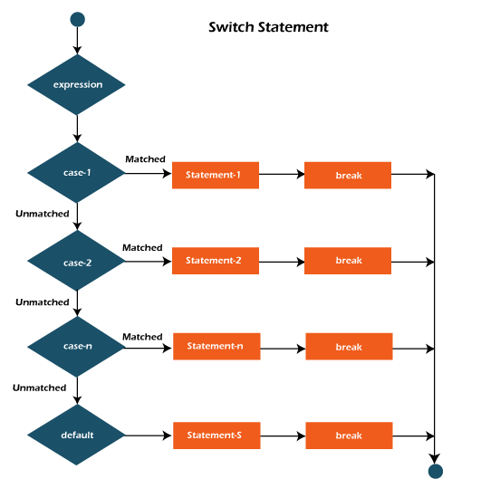

**Example:**

**SwitchExample.java**

1. **public** **class** SwitchExample {
2. **public** **static** **void** main(String[] args) {
3. //Declaring a variable for switch expression
4. **int** number=20;
5. //Switch expression
6. **switch**(number){
7. //Case statements
8. **case** 10: System.out.println("10");
9. **break**;
10. **case** 20: System.out.println("20");
11. **break**;
12. **case** 30: System.out.println("30");
13. **break**;
14. //Default case statement
15. **default**:System.out.println("Not in 10, 20 or 30");
16. }
17. }
18. }

[**Test it Now**](https://compiler.javatpoint.com/opr/test.jsp?filename=SwitchExample)

**Output:**

20

**Finding Month Example:**

**SwitchMonthExample.javaHTML**

1. //Java Program to demonstrate the example of Switch statement
2. //where we are printing month name for the given number
3. **public** **class** SwitchMonthExample {
4. **public** **static** **void** main(String[] args) {
5. //Specifying month number
6. **int** month=7;
7. String monthString="";
8. //Switch statement
9. **switch**(month){
10. //case statements within the switch block
11. **case** 1: monthString="1 - January";
12. **break**;
13. **case** 2: monthString="2 - February";
14. **break**;
15. **case** 3: monthString="3 - March";
16. **break**;
17. **case** 4: monthString="4 - April";
18. **break**;
19. **case** 5: monthString="5 - May";
20. **break**;
21. **case** 6: monthString="6 - June";
22. **break**;
23. **case** 7: monthString="7 - July";
24. **break**;
25. **case** 8: monthString="8 - August";
26. **break**;
27. **case** 9: monthString="9 - September";
28. **break**;
29. **case** 10: monthString="10 - October";
30. **break**;
31. **case** 11: monthString="11 - November";
32. **break**;
33. **case** 12: monthString="12 - December";
34. **break**;
35. **default**:System.out.println("Invalid Month!");
36. }
37. //Printing month of the given number
38. System.out.println(monthString);
39. }
40. }

[**Test it Now**](https://compiler.javatpoint.com/opr/test.jsp?filename=SwitchMonthExample)

**Output:**

7 - July

**Program to check Vowel or Consonant:**

If the character is A, E, I, O, or U, it is vowel otherwise consonant. It is not case-sensitive.

**SwitchVowelExample.java**

1. **public** **class** SwitchVowelExample {
2. **public** **static** **void** main(String[] args) {
3. **char** ch='O';
4. **switch**(ch)
5. {
6. **case** 'a':
7. System.out.println("Vowel");
8. **break**;
9. **case** 'e':
10. System.out.println("Vowel");
11. **break**;
12. **case** 'i':
13. System.out.println("Vowel");
14. **break**;
15. **case** 'o':
16. System.out.println("Vowel");
17. **break**;
18. **case** 'u':
19. System.out.println("Vowel");
20. **break**;
21. **case** 'A':
22. System.out.println("Vowel");
23. **break**;
24. **case** 'E':
25. System.out.println("Vowel");
26. **break**;
27. **case** 'I':
28. System.out.println("Vowel");
29. **break**;
30. **case** 'O':
31. System.out.println("Vowel");
32. **break**;
33. **case** 'U':
34. System.out.println("Vowel");
35. **break**;
36. **default**:
37. System.out.println("Consonant");
38. }
39. }
40. }

**Output:**

Vowel

## Java Switch Statement is fall-through

The Java switch statement is fall-through. It means it executes all statements after the first match if a break statement is not present.

**Example:**

**SwitchExample2.java**

1. //Java Switch Example where we are omitting the
2. //break statement
3. **public** **class** SwitchExample2 {
4. **public** **static** **void** main(String[] args) {
5. **int** number=20;
6. //switch expression with int value
7. **switch**(number){
8. //switch cases without break statements
9. **case** 10: System.out.println("10");
10. **case** 20: System.out.println("20");
11. **case** 30: System.out.println("30");
12. **default**:System.out.println("Not in 10, 20 or 30");
13. }
14. }
15. }

[**Test it Now**](https://compiler.javatpoint.com/opr/test.jsp?filename=SwitchExample2)

**Output:**

20

30

Not in 10, 20 or 30

## Java Switch Statement with String

Java allows us to use strings in switch expression since Java SE 7. The case statement should be string literal.

**Example:**

**SwitchStringExample.java**

1. //Java Program to demonstrate the use of Java Switch
2. //statement with String
3. **public** **class** SwitchStringExample {
4. **public** **static** **void** main(String[] args) {
5. //Declaring String variable
6. String levelString="Expert";
7. **int** level=0;
8. //Using String in Switch expression
9. **switch**(levelString){
10. //Using String Literal in Switch case
11. **case** "Beginner": level=1;
12. **break**;
13. **case** "Intermediate": level=2;
14. **break**;
15. **case** "Expert": level=3;
16. **break**;
17. **default**: level=0;
18. **break**;
19. }
20. System.out.println("Your Level is: "+level);
21. }
22. }

[**Test it Now**](https://compiler.javatpoint.com/opr/test.jsp?filename=SwitchStringExample)

**Output:**

Your Level is: 3

## Java Nested Switch Statement

We can use switch statement inside other switch statement in Java. It is known as nested switch statement.

**Example:**

**NestedSwitchExample.java**

1. //Java Program to demonstrate the use of Java Nested Switch
2. **public** **class** NestedSwitchExample {
3. **public** **static** **void** main(String args[])
4. {
5. //C - CSE, E - ECE, M - Mechanical
6. **char** branch = 'C';
7. **int** collegeYear = 4;
8. **switch**( collegeYear )
9. {
10. **case** 1:
11. System.out.println("English, Maths, Science");
12. **break**;
13. **case** 2:
14. **switch**( branch )
15. {
16. **case** 'C':
17. System.out.println("Operating System, Java, Data Structure");
18. **break**;
19. **case** 'E':
20. System.out.println("Micro processors, Logic switching theory");
21. **break**;
22. **case** 'M':
23. System.out.println("Drawing, Manufacturing Machines");
24. **break**;
25. }
26. **break**;
27. **case** 3:
28. **switch**( branch )
29. {
30. **case** 'C':
31. System.out.println("Computer Organization, MultiMedia");
32. **break**;
33. **case** 'E':
34. System.out.println("Fundamentals of Logic Design, Microelectronics");
35. **break**;
36. **case** 'M':
37. System.out.println("Internal Combustion Engines, Mechanical Vibration");
38. **break**;
39. }
40. **break**;
41. **case** 4:
42. **switch**( branch )
43. {
44. **case** 'C':
45. System.out.println("Data Communication and Networks, MultiMedia");
46. **break**;
47. **case** 'E':
48. System.out.println("Embedded System, Image Processing");
49. **break**;
50. **case** 'M':
51. System.out.println("Production Technology, Thermal Engineering");
52. **break**;
53. }
54. **break**;
55. }
56. }
57. }

[**Test it Now**](https://compiler.javatpoint.com/opr/test.jsp?filename=NestedSwitchExample)

**Output:**

Data Communication and Networks, MultiMedia

## Java Enum in Switch Statement

Java allows us to use enum in switch statement. Java enum is a class that represent the group of constants. (immutable such as final variables). We use the keyword enum and put the constants in curly braces separated by comma.

**Example:**

**JavaSwitchEnumExample.java**

1. //Java Program to demonstrate the use of Enum
2. //in switch statement
3. **public** **class** JavaSwitchEnumExample {
4. **public** **enum** Day {  Sun, Mon, Tue, Wed, Thu, Fri, Sat  }
5. **public** **static** **void** main(String args[])
6. {
7. Day[] DayNow = Day.values();
8. **for** (Day Now : DayNow)
9. {
10. **switch** (Now)
11. {
12. **case** Sun:
13. System.out.println("Sunday");
14. **break**;
15. **case** Mon:
16. System.out.println("Monday");
17. **break**;
18. **case** Tue:
19. System.out.println("Tuesday");
20. **break**;
21. **case** Wed:
22. System.out.println("Wednesday");
23. **break**;
24. **case** Thu:
25. System.out.println("Thursday");
26. **break**;
27. **case** Fri:
28. System.out.println("Friday");
29. **break**;
30. **case** Sat:
31. System.out.println("Saturday");
32. **break**;
33. }
34. }
35. }
36. }

[**Test it Now**](https://compiler.javatpoint.com/opr/test.jsp?filename=JavaSwitchEnumExample)

**Output:**

Sunday

Monday

Twesday

Wednesday

Thursday

Friday

Saturday

## Java Wrapper in Switch Statement

Java allows us to use four [wrapper classes](https://www.javatpoint.com/wrapper-class-in-java): Byte, Short, Integer and Long in switch statement.

**Example:**

**WrapperInSwitchCaseExample.java**

1. //Java Program to demonstrate the use of Wrapper class
2. //in switch statement
3. **public** **class** WrapperInSwitchCaseExample {
4. **public** **static** **void** main(String args[])
5. {
6. Integer age = 18;
7. **switch** (age)
8. {
9. **case** (16):
10. System.out.println("You are under 18.");
11. **break**;
12. **case** (18):
13. System.out.println("You are eligible for vote.");
14. **break**;
15. **case** (65):
16. System.out.println("You are senior citizen.");
17. **break**;
18. **default**:
19. System.out.println("Please give the valid age.");
20. **break**;
21. }
22. }
23. }

# Loops in Java

The Java for loop is used to iterate a part of the program several times. If the number of iteration is **fixed**, it is recommended to use for loop.

There are three types of for loops in Java.

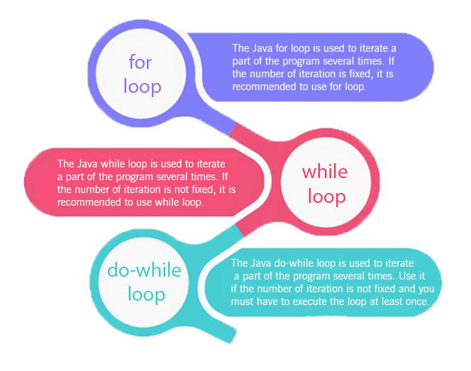

* Simple for Loop
* [For-each](https://www.javatpoint.com/for-each-loop) or Enhanced for Loop
* Labeled for Loop

## Java Simple for Loop

A simple for loop is the same as [C](https://www.javatpoint.com/c-programming-language-tutorial)/[C++](https://www.javatpoint.com/cpp-tutorial). We can initialize the [variable](https://www.javatpoint.com/java-variables), check condition and increment/decrement value. It consists of four parts:

1. **Initialization**: It is the initial condition which is executed once when the loop starts. Here, we can initialize the variable, or we can use an already initialized variable. It is an optional condition.
2. **Condition**: It is the second condition which is executed each time to test the condition of the loop. It continues execution until the condition is false. It must return boolean value either true or false. It is an optional condition.
3. **Increment/Decrement**: It increments or decrements the variable value. It is an optional condition.
4. **Statement**: The statement of the loop is executed each time until the second condition is false.

**Syntax:**

1. **for**(initialization; condition; increment/decrement){
2. //statement or code to be executed
3. }

**Flowchart:**

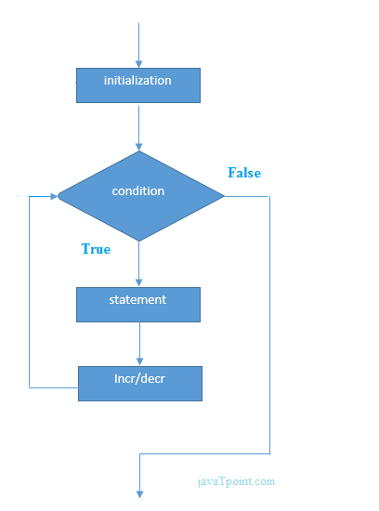

**Example:**

**ForExample.java**

1. //Java Program to demonstrate the example of for loop
2. //which prints table of 1
3. **public** **class** ForExample {
4. **public** **static** **void** main(String[] args) {
5. //Code of Java for loop
6. **for**(**int** i=1;i<=10;i++){
7. System.out.println(i);
8. }
9. }
10. }

[**Test it Now**](https://compiler.javatpoint.com/opr/test.jsp?filename=ForExample)

**Output:**

1

2

3

4

5

6

7

8

9

10

## Java Nested for Loop

If we have a for loop inside the another loop, it is known as nested for loop. The inner loop executes completely whenever outer loop executes.

**Example:**

**NestedForExample.java**

1. **public** **class** NestedForExample {
2. **public** **static** **void** main(String[] args) {
3. //loop of i
4. **for**(**int** i=1;i<=3;i++){
5. //loop of j
6. **for**(**int** j=1;j<=3;j++){
7. System.out.println(i+" "+j);
8. }//end of i
9. }//end of j
10. }
11. }

**Output:**

1 1

1 2

1 3

2 1

2 2

2 3

3 1

3 2

3 3

**Pyramid Example 1:**

**PyramidExample.java**

1. **public** **class** PyramidExample {
2. **public** **static** **void** main(String[] args) {
3. **for**(**int** i=1;i<=5;i++){
4. **for**(**int** j=1;j<=i;j++){
5. System.out.print("* ");
6. }
7. System.out.println();//new line
8. }
9. }
10. }

**Output:**

*

* *

* * *

* * * *

* * * * *

**Pyramid Example 2:**

**PyramidExample2.java**

1. **public** **class** PyramidExample2 {
2. **public** **static** **void** main(String[] args) {
3. **int** term=6;
4. **for**(**int** i=1;i<=term;i++){
5. **for**(**int** j=term;j>=i;j--){
6. System.out.print("* ");
7. }
8. System.out.println();//new line
9. }
10. }
11. }

**Output:**

* * * * * *

* * * * *

* * * *

* * *

* *

*

## Java for-each Loop

The for-each loop is used to traverse array or collection in Java. It is easier to use than simple for loop because we don't need to increment value and use subscript notation.

It works on the basis of elements and not the index. It returns element one by one in the defined variable.

**Syntax:**

1. **for**(data_type variable : array_name){
2. //code to be executed
3. }

**Example:**

**ForEachExample.java**

1. //Java For-each loop example which prints the
2. //elements of the array
3. **public** **class** ForEachExample {
4. **public** **static** **void** main(String[] args) {
5. //Declaring an array
6. **int** arr[]={12,23,44,56,78};
7. //Printing array using for-each loop
8. **for**(**int** i:arr){
9. System.out.println(i);
10. }
11. }
12. }

[**Test it Now**](https://compiler.javatpoint.com/opr/test.jsp?filename=ForEachExample)

**Output:**

12

23

44

56

78

## Java Labeled For Loop

We can have a name of each Java for loop. To do so, we use label before the for loop. It is useful while using the nested for loop as we can break/continue specific for loop.

#### Note: The break and continue keywords breaks or continues the innermost for loop respectively.

**Syntax:**

1. labelname:
2. **for**(initialization; condition; increment/decrement){
3. //code to be executed
4. }

**Example:**

**LabeledForExample.java**

1. //A Java program to demonstrate the use of labeled for loop
2. **public** **class** LabeledForExample {
3. **public** **static** **void** main(String[] args) {
4. //Using Label for outer and for loop
5. aa:
6. **for**(**int** i=1;i<=3;i++){
7. bb:
8. **for**(**int** j=1;j<=3;j++){
9. **if**(i==2&&j==2){
10. **break** aa;
11. }
12. System.out.println(i+" "+j);
13. }
14. }
15. }
16. }

**Output:**

1 1

1 2

1 3

2 1

If you use **break bb;**, it will break inner loop only which is the default behaviour of any loop.

**LabeledForExample2.java**

1. **public** **class** LabeledForExample2 {
2. **public** **static** **void** main(String[] args) {
3. aa:
4. **for**(**int** i=1;i<=3;i++){
5. bb:
6. **for**(**int** j=1;j<=3;j++){
7. **if**(i==2&&j==2){
8. **break** bb;
9. }
10. System.out.println(i+" "+j);
11. }
12. }
13. }
14. }

**Output:**

1 1

1 2

1 3

2 1

3 1

3 2

3 3

## Java Infinitive for Loop

If you use two semicolons ;; in the for loop, it will be infinitive for loop.

**Syntax:**

1. **for**(;;){
2. //code to be executed
3. }
4. **ForExample.java**
5. //Java program to demonstrate the use of infinite for loop
6. //which prints an statement
7. **public** **class** ForExample {
8. **public** **static** **void** main(String[] args) {
9. //Using no condition in for loop
10. **for**(;;){
11. System.out.println("infinitive loop");
12. }
13. }
14. }

**Output:**

infinitive loop

infinitive loop

infinitive loop

infinitive loop

infinitive loop

ctrl+c

Now, you need to press ctrl+c to exit from the program.

## Java for Loop vs while Loop vs do-while Loop

|  |  |  |  |
| --- | --- | --- | --- |
| **Comparison** | **for loop** | **while loop** | **do-while loop** |
| Introduction | The Java for loop is a control flow statement that iterates a part of the [programs](https://www.javatpoint.com/java-programs) multiple times. | The Java while loop is a control flow statement that executes a part of the programs repeatedly on the basis of given boolean condition. | The Java do while loop is a control flow statement that executes a part of the programs at least once and the further execution depends upon the given boolean condition. |
| When to use | If the number of iteration is fixed, it is recommended to use for loop. | If the number of iteration is not fixed, it is recommended to use while loop. | If the number of iteration is not fixed and you must have to execute the loop at least once, it is recommended to use the do-while loop. |
| Syntax | for(init;condition;incr/decr){ // code to be executed } | while(condition){ //code to be executed } | do{ //code to be executed }while(condition); |
| Example | //for loop for(int i=1;i<=10;i++){ System.out.println(i); } | //while loop int i=1; while(i<=10){ System.out.println(i); i++; } | //do-while loop int i=1; do{ System.out.println(i); i++; }while(i<=10); |
| Syntax for infinitive loop | for(;;){ //code to be executed } | while(true){ //code to be executed } | do{ //code to be executed }while(true); |

# Java While Loop

The [Java](https://www.javatpoint.com/java-tutorial) while loop is used to iterate a part of the [program](https://www.javatpoint.com/programs-list) repeatedly until the specified Boolean condition is true. As soon as the Boolean condition becomes false, the loop automatically stops.

The while loop is considered as a repeating if statement. If the number of iteration is not fixed, it is recommended to use the while [loop](https://www.javatpoint.com/java-for-loop).

**Syntax:**

1. **while** (condition){
2. //code to be executed
3. I ncrement / decrement statement
4. }

**The different parts of do-while loop:**

1. Condition: It is an expression which is tested. If the condition is true, the loop body is executed and control goes to update expression. When the condition becomes false, we exit the while loop.

**Example**:

i <=100

2. Update expression: Every time the loop body is executed, this expression increments or decrements loop variable.

**Example:**

**i++;**

**Flowchart of Java While Loop**

Here, the important thing about while loop is that, sometimes it may not even execute. If the condition to be tested results into false, the loop body is skipped and first statement after the while loop will be executed.

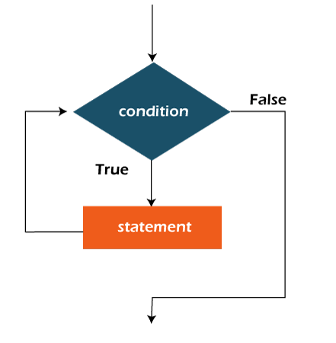

**Example:**

In the below example, we print integer values from 1 to 10. Unlike the for loop, we separately need to initialize and increment the variable used in the condition (here, i). Otherwise, the loop will execute infinitely.

**WhileExample.java**

1. **public** **class** WhileExample {
2. **public** **static** **void** main(String[] args) {
3. **int** i=1;
4. **while**(i<=10){
5. System.out.println(i);
6. i++;
7. }
8. }
9. }

[**Test it Now**](https://compiler.javatpoint.com/opr/test.jsp?filename=WhileExample)

**Output:**

1

2

3

4

5

6

7

8

9

10

## Java Infinitive While Loop

If you pass **true** in the while loop, it will be infinitive while loop.

**Syntax:**

1. **while**(**true**){
2. //code to be executed
3. }

**Example:**

**WhileExample2.java**

1. **public** **class** WhileExample2 {
2. **public** **static** **void** main(String[] args) {
3. // setting the infinite while loop by passing true to the condition
4. **while**(**true**){
5. System.out.println("infinitive while loop");
6. }
7. }
8. }

**Output:**

infinitive while loop

infinitive while loop

infinitive while loop

infinitive while loop

infinitive while loop

ctrl+c

In the above code, we need to enter Ctrl + C command to terminate the infinite loop.

# Java do-while Loop

The Java do-while loop is used to iterate a part of the program repeatedly, until the specified condition is true. If the number of iteration is not fixed and you must have to execute the loop at least once, it is recommended to use a do-while loop.

Java do-while loop is called an **exit control loop**. Therefore, unlike while loop and for loop, the do-while check the condition at the end of loop body. The Java do-while loop is executed at least once because condition is checked after loop body.

**Syntax:**

1. **do**{
2. //code to be executed / loop body
3. //update statement
4. }**while** (condition);

**The different parts of do-while loop:**

1. Condition: It is an expression which is tested. If the condition is true, the loop body is executed and control goes to update expression. As soon as the condition becomes false, loop breaks automatically.

**Example:**

**i <=100**

2. Update expression: Every time the loop body is executed, the this expression increments or decrements loop variable.

**Example:**

**i++;**

#### Note: The do block is executed at least once, even if the condition is false.

**Flowchart of do-while loop:**

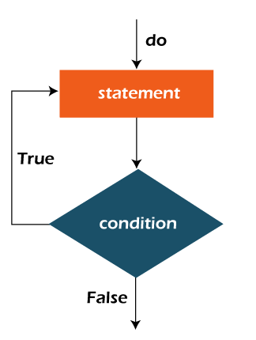

**Example:**

In the below example, we print integer values from 1 to 10. Unlike the for loop, we separately need to initialize and increment the variable used in the condition (here, i). Otherwise, the loop will execute infinitely.

**DoWhileExample.java**

1. **public** **class** DoWhileExample {
2. **public** **static** **void** main(String[] args) {
3. **int** i=1;
4. **do**{
5. System.out.println(i);
6. i++;
7. }**while**(i<=10);
8. }
9. }

[**Test it Now**](https://compiler.javatpoint.com/opr/test.jsp?filename=DoWhileExample)

**Output:**

1

2

3

4

5

6

7

8

9

10

## Java Infinitive do-while Loop

If you pass **true** in the do-while loop, it will be infinitive do-while loop.

**Syntax:**

1. **do**{
2. //code to be executed
3. }**while**(**true**);

**Example:**

**DoWhileExample2.java**

1. **public** **class** DoWhileExample2 {
2. **public** **static** **void** main(String[] args) {
3. **do**{
4. System.out.println("infinitive do while loop");
5. }**while**(**true**);
6. }
7. }

**Output:**

infinitive do while loop

infinitive do while loop

infinitive do while loop

ctrl+c

In the above code, we need to enter Ctrl + C command to terminate the infinite loop.

# Java Break Statement

When a break statement is encountered inside a loop, the loop is immediately terminated and the program control resumes at the next statement following the loop.

The Java break statement is used to break loop or [switch](https://www.javatpoint.com/java-switch) statement. It breaks the current flow of the program at specified condition. In case of inner loop, it breaks only inner loop.

We can use Java break statement in all types of loops such as [for loop](https://www.javatpoint.com/java-for-loop), [while loop](https://www.javatpoint.com/java-while-loop) and [do-while loop](https://www.javatpoint.com/java-do-while-loop).

**Syntax:**

1. jump-statement;
2. **break**;

**Flowchart of Break Statement**

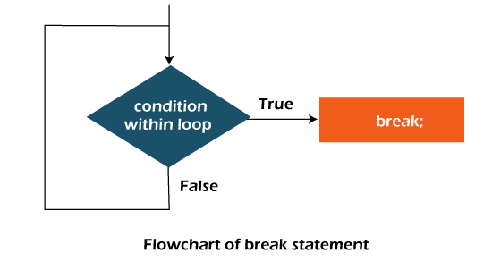

## Java Break Statement with Loop

**Example:**

**BreakExample.java**

1. //Java Program to demonstrate the use of break statement
2. //inside the for loop.
3. **public** **class** BreakExample {
4. **public** **static** **void** main(String[] args) {
5. //using for loop
6. **for**(**int** i=1;i<=10;i++){
7. **if**(i==5){
8. //breaking the loop
9. **break**;
10. }
11. System.out.println(i);
12. }
13. }
14. }

**Output:**

1

2

3

4

## Java Break Statement with Inner Loop

It breaks inner loop only if you use break statement inside the inner loop.

**Example:**

**BreakExample2.java**

1. //Java Program to illustrate the use of break statement
2. //inside an inner loop
3. **public** **class** BreakExample2 {
4. **public** **static** **void** main(String[] args) {
5. //outer loop
6. **for**(**int** i=1;i<=3;i++){
7. //inner loop
8. **for**(**int** j=1;j<=3;j++){
9. **if**(i==2&&j==2){
10. //using break statement inside the inner loop
11. **break**;
12. }
13. System.out.println(i+" "+j);
14. }
15. }
16. }
17. }

**Output:**

1 1

1 2

1 3

2 1

3 1

3 2

3 3

## Java Break Statement with Labeled For Loop

We can use break statement with a label. The feature is introduced since JDK 1.5. So, we can break any loop in Java now whether it is outer or inner loop.

**Example:**

**BreakExample3.java**

1. //Java Program to illustrate the use of continue statement
2. //with label inside an inner loop to break outer loop
3. **public** **class** BreakExample3 {
4. **public** **static** **void** main(String[] args) {
5. aa:
6. **for**(**int** i=1;i<=3;i++){
7. bb:
8. **for**(**int** j=1;j<=3;j++){
9. **if**(i==2&&j==2){
10. //using break statement with label
11. **break** aa;
12. }
13. System.out.println(i+" "+j);
14. }
15. }
16. }
17. }

**Output:**

1 1

1 2

1 3

2 1

## Java Break Statement in while loop

**Example:**

**BreakWhileExample.java**

1. //Java Program to demonstrate the use of break statement
2. //inside the while loop.
3. **public** **class** BreakWhileExample {
4. **public** **static** **void** main(String[] args) {
5. //while loop
6. **int** i=1;
7. **while**(i<=10){
8. **if**(i==5){
9. //using break statement
10. i++;
11. **break**;//it will break the loop
12. }
13. System.out.println(i);
14. i++;
15. }
16. }
17. }

**Output:**

1

2

3

4

## Java Break Statement in do-while loop

**Example:**

**BreakDoWhileExample.java**

1. //Java Program to demonstrate the use of break statement
2. //inside the Java do-while loop.
3. **public** **class** BreakDoWhileExample {
4. **public** **static** **void** main(String[] args) {
5. //declaring variable
6. **int** i=1;
7. //do-while loop
8. **do**{
9. **if**(i==5){
10. //using break statement
11. i++;
12. **break**;//it will break the loop
13. }
14. System.out.println(i);
15. i++;
16. }**while**(i<=10);
17. }
18. }

**Output:**

1

2

3

4

## Java Break Statement with Switch

To understand the example of break with switch statement, please visit here: [Java Switch Statement](https://www.javatpoint.com/java-switch).

# Java Continue Statement

The continue statement is used in loop control structure when you need to jump to the next iteration of the loop immediately. It can be used with for loop or while loop.

The Java continue statement is used to continue the loop. It continues the current flow of the program and skips the remaining code at the specified condition. In case of an inner loop, it continues the inner loop only.

We can use Java continue statement in all types of loops such as for loop, while loop and do-while loop.

**Syntax:**

1. jump-statement;
2. **continue**;

## Java Continue Statement Example

**ContinueExample.java**

1. //Java Program to demonstrate the use of continue statement
2. //inside the for loop.
3. **public** **class** ContinueExample {
4. **public** **static** **void** main(String[] args) {
5. //for loop
6. **for**(**int** i=1;i<=10;i++){
7. **if**(i==5){
8. //using continue statement
9. **continue**;//it will skip the rest statement
10. }
11. System.out.println(i);
12. }
13. }
14. }

[**Test it Now**](https://compiler.javatpoint.com/opr/test.jsp?filename=ContinueExample)

**Output:**

1

2

3

4

6

7

8

9

10

As you can see in the above output, 5 is not printed on the console. It is because the loop is continued when it reaches to 5.

## Java Continue Statement with Inner Loop

It continues inner loop only if you use the continue statement inside the inner loop.

**ContinueExample2.java**

1. //Java Program to illustrate the use of continue statement
2. //inside an inner loop
3. **public** **class** ContinueExample2 {
4. **public** **static** **void** main(String[] args) {
5. //outer loop
6. **for**(**int** i=1;i<=3;i++){
7. //inner loop
8. **for**(**int** j=1;j<=3;j++){
9. **if**(i==2&&j==2){
10. //using continue statement inside inner loop
11. **continue**;
12. }
13. System.out.println(i+" "+j);
14. }
15. }
16. }
17. }

**Output:**

1 1

1 2

1 3

2 1

2 3

3 1

3 2

3 3

## Java Continue Statement with Labelled For Loop

We can use continue statement with a label. This feature is introduced since JDK 1.5. So, we can continue any loop in Java now whether it is outer loop or inner.

**Example:**

**ContinueExample3.java**

1. //Java Program to illustrate the use of continue statement
2. //with label inside an inner loop to continue outer loop
3. **public** **class** ContinueExample3 {
4. **public** **static** **void** main(String[] args) {
5. aa:
6. **for**(**int** i=1;i<=3;i++){
7. bb:
8. **for**(**int** j=1;j<=3;j++){
9. **if**(i==2&&j==2){
10. //using continue statement with label
11. **continue** aa;
12. }
13. System.out.println(i+" "+j);
14. }
15. }
16. }
17. }

**Output:**

1 1

1 2

1 3

2 1

3 1

3 2

3 3

## Java Continue Statement in while loop

**ContinueWhileExample.java**

1. //Java Program to demonstrate the use of continue statement
2. //inside the while loop.
3. **public** **class** ContinueWhileExample {
4. **public** **static** **void** main(String[] args) {
5. //while loop
6. **int** i=1;
7. **while**(i<=10){
8. **if**(i==5){
9. //using continue statement
10. i++;
11. **continue**;//it will skip the rest statement
12. }
13. System.out.println(i);
14. i++;
15. }
16. }
17. }

[**Test it Now**](https://compiler.javatpoint.com/opr/test.jsp?filename=ContinueWhileExample)

**Output:**

1

2

3

4

6

7

8

9

10

## Java Continue Statement in do-while Loop

**ContinueDoWhileExample.java**

1. //Java Program to demonstrate the use of continue statement
2. //inside the Java do-while loop.
3. **public** **class** ContinueDoWhileExample {
4. **public** **static** **void** main(String[] args) {
5. //declaring variable
6. **int** i=1;
7. //do-while loop
8. **do**{
9. **if**(i==5){
10. //using continue statement
11. i++;
12. **continue**;//it will skip the rest statement
13. }
14. System.out.println(i);
15. i++;
16. }**while**(i<=10);
17. }
18. }

[**Test it Now**](https://compiler.javatpoint.com/opr/test.jsp?filename=ContinueDoWhileExample)

**Output:**

1

2

3

4

6

7

8

9

10

# Java Comments

The [Java](https://www.javatpoint.com/java-tutorial) comments are the statements in a program that are not executed by the compiler and interpreter.

## Why do we use comments in a code?

* Comments are used to make the program more readable by adding the details of the code.
* It makes easy to maintain the code and to find the errors easily.
* The comments can be used to provide information or explanation about the [variable](https://www.javatpoint.com/java-variables), method, [class](https://www.javatpoint.com/object-and-class-in-java), or any statement.
* It can also be used to prevent the execution of program code while testing the alternative code.

## Types of Java Comments

There are three types of comments in Java.

1. Single Line Comment
2. Multi Line Comment
3. Documentation Comment

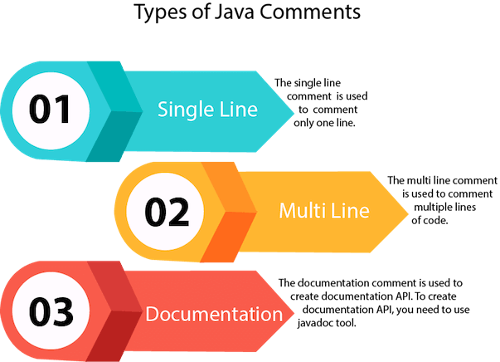

### 1) Java Single Line Comment

The single-line comment is used to comment only one line of the code. It is the widely used and easiest way of commenting the statements.

Single line comments starts with two forward slashes **(//)**. Any text in front of // is not executed by Java.

**Syntax:**

1. //This is single line comment

Let's use single line comment in a Java program.

**CommentExample1.java**

1. **public** **class** CommentExample1 {
2. **public** **static** **void** main(String[] args) {
3. **int** i=10; // i is a variable with value 10
4. System.out.println(i);  //printing the variable i
5. }
6. }

**Output:**

10

### 2) Java Multi Line Comment

The multi-line comment is used to comment multiple lines of code. It can be used to explain a complex code snippet or to comment multiple lines of code at a time (as it will be difficult to use single-line comments there).

Multi-line comments are placed between /* and */. Any text between /* and */ is not executed by Java.

**Syntax:**

1. /*
2. This
3. is
4. multi line
5. comment
6. */

Let's use multi-line comment in a Java program.

**CommentExample2.java**

1. **public** **class** CommentExample2 {
2. **public** **static** **void** main(String[] args) {
3. /* Let's declare and
4. print variable in java. */
5. **int** i=10;
6. System.out.println(i);
7. /* float j = 5.9;
8. float k = 4.4;
9. System.out.println( j + k ); */
10. }
11. }

**Output:**

10

#### Note: Usually // is used for short comments and /* */ is used for longer comments.

### 3) Java Documentation Comment

Documentation comments are usually used to write large programs for a project or software application as it helps to create documentation API. These APIs are needed for reference, i.e., which classes, methods, arguments, etc., are used in the code.

To create documentation API, we need to use the **[javadoc tool](https://www.javatpoint.com/creating-api-document)**. The documentation comments are placed between /** and */.

**Syntax:**

1. /**
2. *
3. *We can use various tags to depict the parameter
4. *or heading or author name
5. *We can also use HTML tags
6. *
7. */

## javadoc tags

Some of the commonly used tags in documentation comments:

|  |  |  |
| --- | --- | --- |
| **Tag** | **Syntax** | **Description** |
| {@docRoot} | {@docRoot} | to depict relative path to root directory of generated document from any page. |
| @author | @author name - text | To add the author of the class. |
| @code | {@code text} | To show the text in code font without interpreting it as html markup or nested javadoc tag. |
| @version | @version version-text | To specify "Version" subheading and version-text when -version option is used. |
| @since | @since release | To add "Since" heading with since text to generated documentation. |
| @param | @param parameter-name description | To add a parameter with given name and description to 'Parameters' section. |
| @return | @return description | Required for every method that returns something (except void) |

Let's use the Javadoc tag in a Java program.

**Calculate.java**

1. **import** java.io.*;
3. /**
4. * <h2> Calculation of numbers </h2>
5. * This program implements an application
6. * to perform operation such as addition of numbers
7. * and print the result
8. * <p>
9. * <b>Note:</b> Comments make the code readable and
10. * easy to understand.
11. *
12. * @author Anurati
13. * @version 16.0
14. * @since 2021-07-06
15. */
17. **public** **class** Calculate{
18. /**
19. * This method calculates the summation of two integers.
20. * @param input1 This is the first parameter to sum() method
21. * @param input2 This is the second parameter to the sum() method.
22. * @return int This returns the addition of input1 and input2
23. */
24. **public** **int** sum(**int** input1, **int** input2){
25. **return** input1 + input2;
26. }
27. /**
28. * This is the main method uses of sum() method.
29. * @param args Unused
30. * @see IOException
31. */
32. **public** **static** **void** main(String[] args) {
33. Calculate obj = **new** Calculate();
34. **int** result = obj.sum(40, 20);
36. System.out.println("Addition of numbers: " + result);
37. }
38. }

Compile it by javac tool:

Create Document

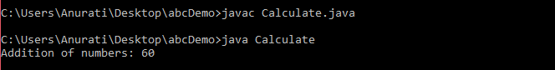

Create documentation API by **javadoc** tool:

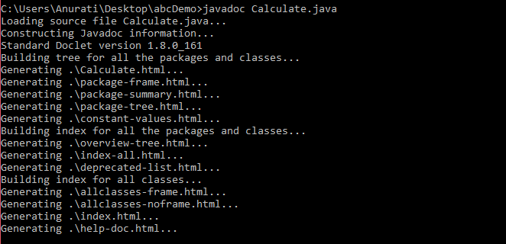

Now, the [HTML](https://www.javatpoint.com/html-tutorial) files are created for the **Calculate** class in the current directory, i.e., **abcDemo**. Open the HTML files, and we can see the explanation of Calculate class provided through the documentation comment.

## Are Java comments executable?

**Ans:** As we know, Java comments are not executed by the compiler or interpreter, however, before the lexical transformation of code in compiler, contents of the code are encoded into ASCII in order to make the processing easy.

**Test.java**

1. **public** **class** Test{
2. **public** **static** **void** main(String[] args) {
3. //the below comment will be executed
4. // \u000d System.out.println("Java comment is executed!!");
5. }
6. }

**Output:**

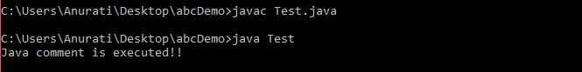

The above code generate the output because the compiler parses the Unicode character \**u000d** as a **new line** before the lexical transformation, and thus the code is transformed as shown below:

**Test.java**

1. **public** **class** Test{
2. **public** **static** **void** main(String[] args) {
3. //the below comment will be executed
4. //
5. System.out.println("Java comment is executed!!");
6. }
7. }

Thus, the Unicode character shifts the print statement to next line and it is executed as a normal Java code.

# Java Escape Characters

In this section, we will discuss **Java escape characters** or **escape sequences**. Also, we will use these **escape sequences or characters in a Java program**.

## What are escape characters?

In Java, if a character is preceded by a **backslash** (\) is known as **Java escape sequence** or **escape characters**. It may include **letters, numerals, punctuations,** etc. Remember that escape characters must be enclosed in **quotation marks** (""). These are the valid character literals. The Java compiler interprets these characters as a single character that adds a specific meaning to the compiler.

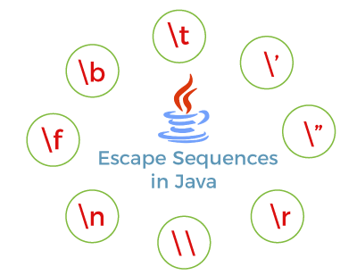

## List of Java Escape Characters

In Java, there is a total of eight escape sequences that are described in the following table.

|  |  |
| --- | --- |
| **Escape Characters** | **Description** |
| **\t** | It is used to insert a **tab** in the text at this point. |
| **\'** | It is used to insert a **single quote** character in the text at this point. |
| **\"** | It is used to insert a **double quote** character in the text at this point. |
| **\r** | It is used to insert a **carriage return** in the text at this point. |
| **\\** | It is used to insert a **backslash character** in the text at this point. |
| **\n** | It is used to insert a **new line** in the text at this point. |
| **\f** | It is used to insert a **form feed** in the text at this point. |
| **\b** | It is used to insert a **backspace** in the text at this point. |

## Why do we use escape characters?

Let's understand the uses of escape characters through the following example. Suppose, we have to print the following statement with double quotes:

1. "Java" is an object-oriented programming language.

The following statements do not print Java enclosed in quotation marks.

1. System.out.println("Java is an object-oriented programming language.");
2. System.out.println(""Java" is an object-oriented programming language.");

While we compile the program with the above two statements, the compiler gives errors, as shown below.

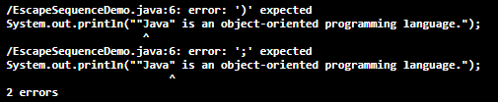

In such a case, the compiler needs to be told that quotation marks do not signal the start or end of a string, but instead are to be printed. The following statement prints statements with **quotation marks.**

1. System.out.println("\"Java\" is an object-oriented programming language.")

### Understanding Java Access Modifiers

Let's understand the access modifiers in Java by a simple table.

|  |  |  |  |  |
| --- | --- | --- | --- | --- |
| **Access Modifier** | **within class** | **within package** | **outside package by subclass only** | **outside package** |
| **Private** | Y | N | N | N |
| **Default** | Y | Y | N | N |
| **Protected** | Y | Y | Y | N |
| **Public** | Y | Y | Y | Y |